- In the Safari Booking List, the placeholder name for the safari dropdown is displayed incorrectly. Additionally, the placeholder name is not clearly visible, and the dropdown symbol is missing.

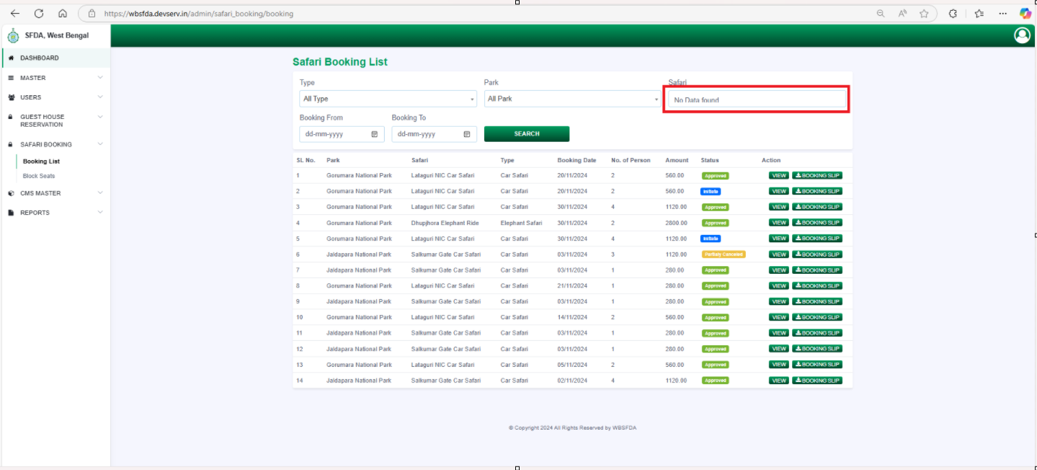

- In the Safari Block List, the placeholder name for the safari dropdown is displayed incorrectly.

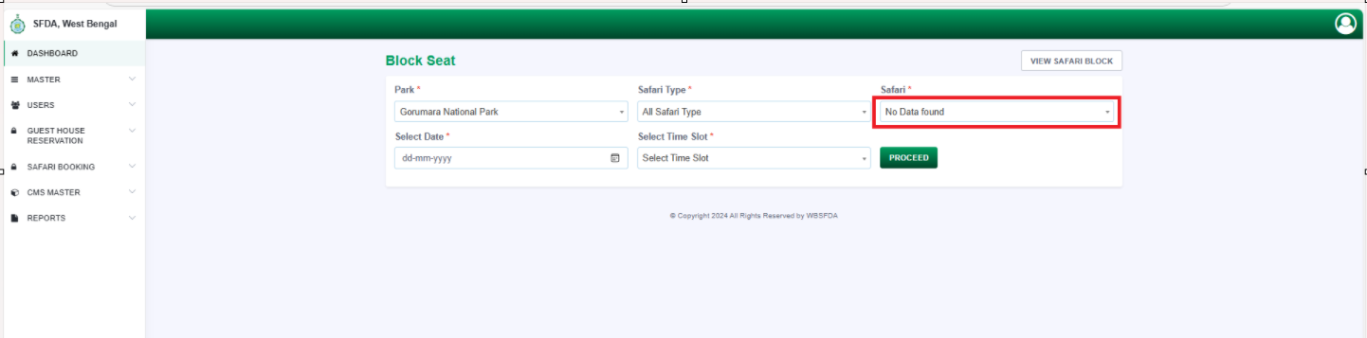

- In Block History, change the action button name to 'Revoke' as “Unblock”.

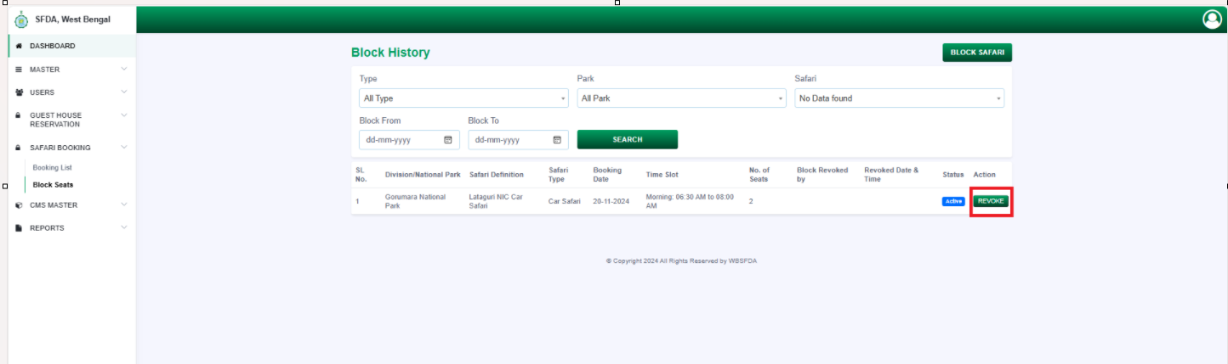

- In Block History, change the action button name to 'Terminate'.

